



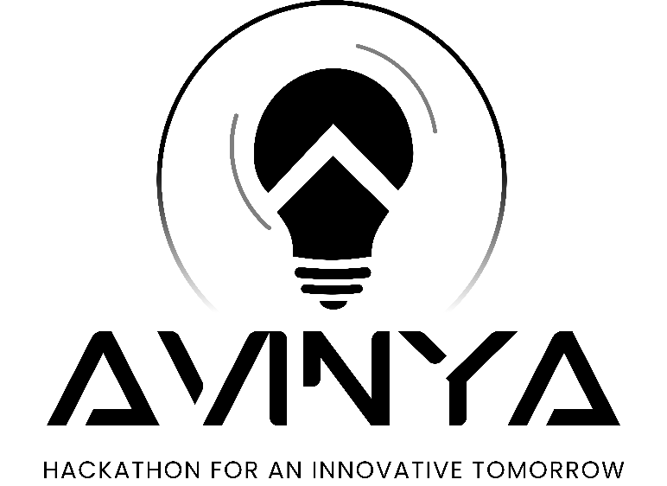





**Team Name :**

**Team Leader :**

**Team Members :**

**Problem Statement :**



**Problem Identified :**

*(Describe the problem you have selected for which you are developing a solution.)*

**Market Research :**

*(Try answering these questions :*

*Who are your customers and end-users?*

*What are solutions already available in market for your problem? How is your solution better than existing solutions?*

*what impact will your project make on the current market?*



**Project Name :**

**Describe your solution :**



**Technology stack :**

*(Technologies used for developing the project)*

**Innovativeness :**

**Show Stoppers :**

*(Show stoppers are obstacles and risks that may arise in the future and which may come in the way of your solution.)*

**Prototype :**

*(You can add sketches, pictures, wireframe, UI or provide a video link in which prototype is explained.)*

*(This section carries maximum weightage)*





**Use case Digram/flow Diagram :** 